KOREAN TRADITIONAL DANCE
presented by
DANKOOK UNIVERSITY, SOUTH KOREA
In celebration of International Education Week (November 15-19, 2010) and the establishment of the CSULB-Dankook University
Student and Faculty Exchange Program
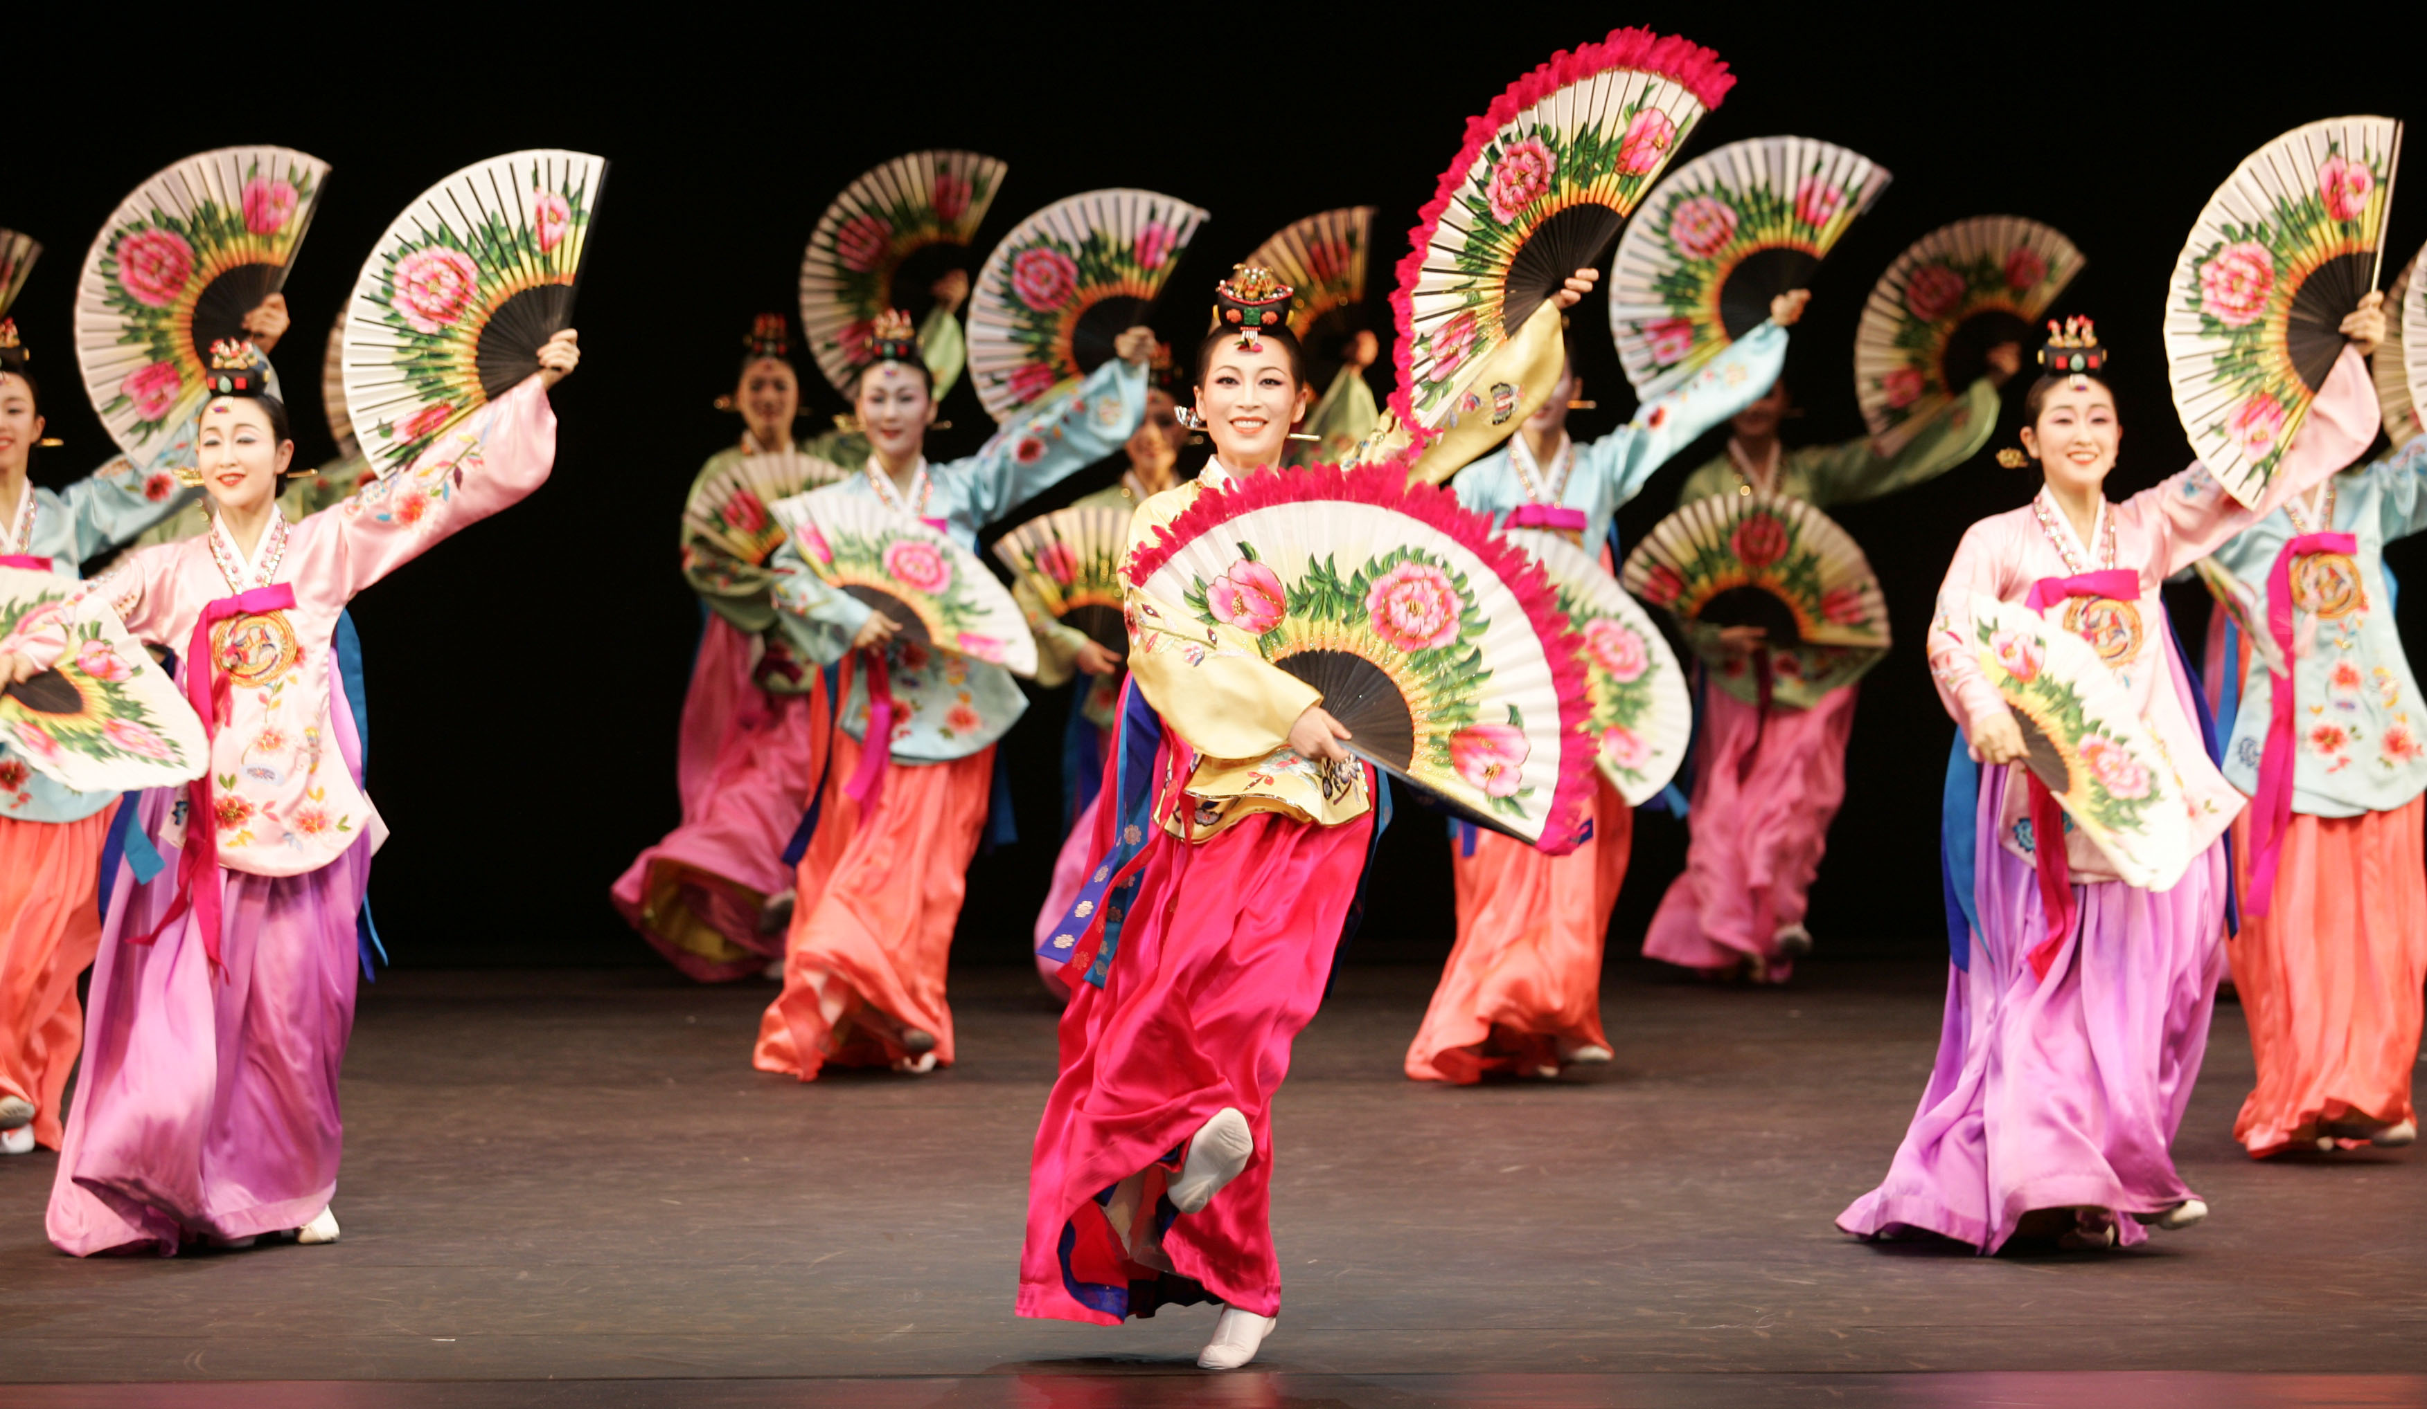
Date & Time: Friday, November 19, 2010 7:30 p.m.
Place: University Theater, California State University, Long Beach
Co-sponsors: Office of the President, Office of the Provost, College of
Liberal Arts, Asian and Asian American Studies
Department, and Center for International Education
Free Admission
For further information, please call (562) 985-4645.

