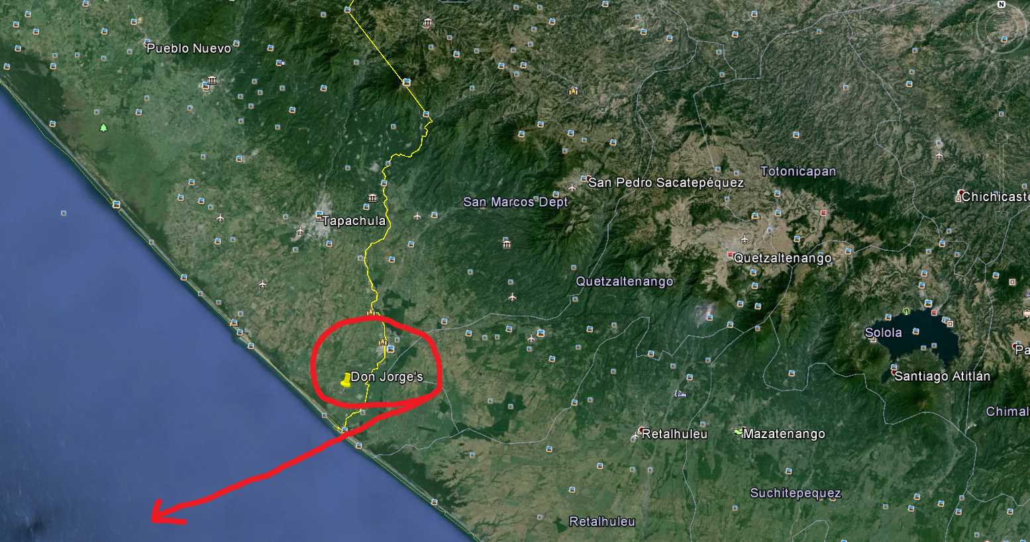
CSULB WINTER 2014
Archeological Field Trip
Working with archaeological collections from past season’s fieldwork

Chiapas Mexico
January 3 through January 26, 2014

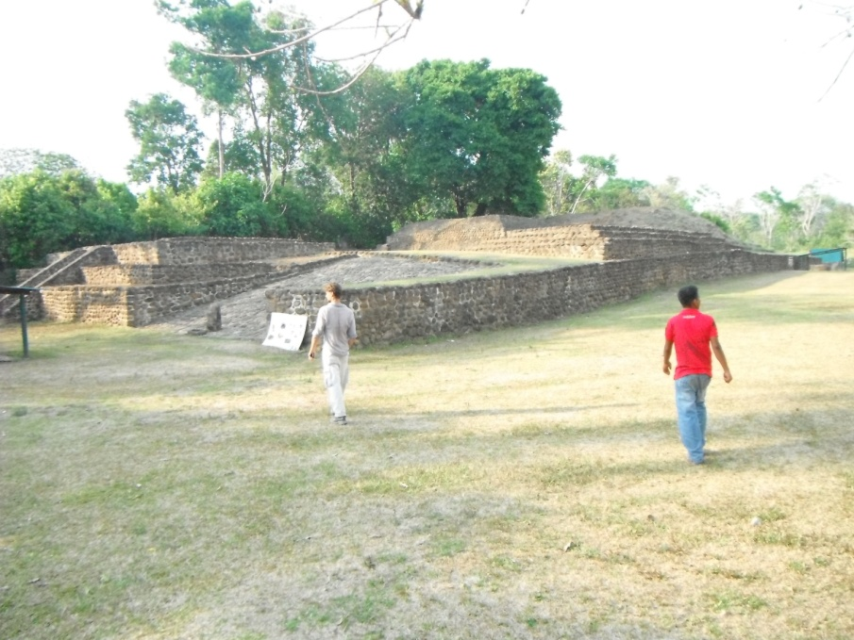
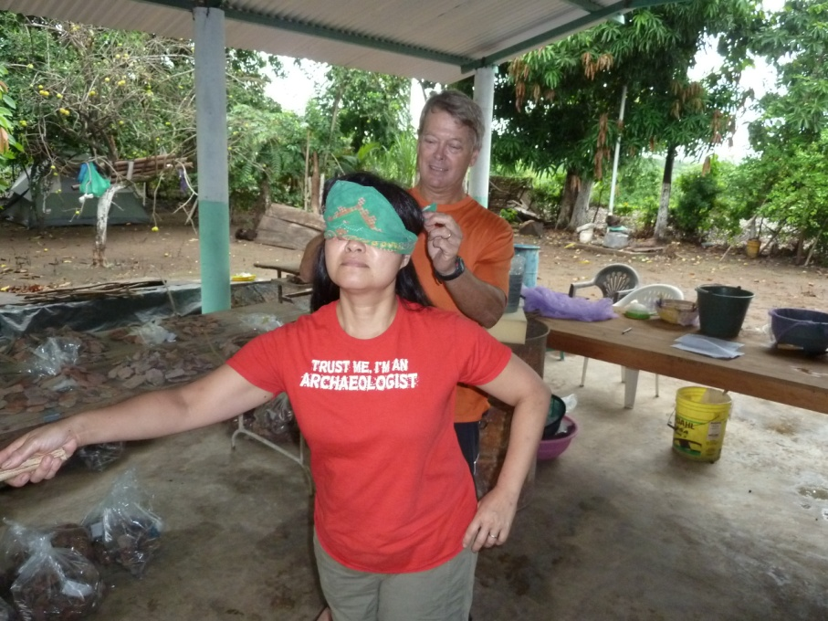

For more information contact
Dr. Hector Neff at hector.neff@csulb.edu

Specifics on the trip:

We will be flying in to Tapachula, Chiapas, which is on the Pacific coastal plain of far-southern Mexico, a region known as Soconusco. Our home base will be in the ejido of Cuauhtemoc, a rural Mexican town about 5 km inland from the Pacific Ocean and 5 km northwest of the Guatemalan border.

The work will consist in large part of sorting large collections of artifacts, mostly pottery, generated by three previous seasons of fieldwork. We will be recording descriptive information and carrying out some analyses, such as XRF and FTIR, in the field laboratory. We will also be selecting samples for export back to Long Beach for further analysis.

Although we won’t be doing fieldwork, we will visit some of the sites where we have worked previously, which are located in the mangrove swamp that extends along the Soconusco coast. Field trips on days off will include visits to the piedmont site of Izapa and the Tapachula archaeological museum. We will also try to arrange a trip to Guatemala, to visit the archaeological site of Takalik Abaj.

