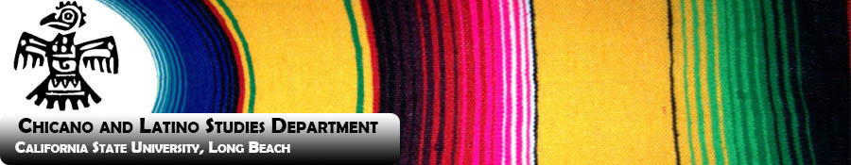
FALL 2015 CHLS Student/Faculty Mixer
Save the Date: Wednesday, September 23rd
12:00- 2:00 p.m.
@ The Anatol Center (AS building)
- Come meet the faculty and staff in the Chicano and Latino Studies Department and hear about the exciting new initiatives in the Humanities and the Arts, as well as in our revamped curriculum. Ask us how you can Earn More in 4 and become much more marketable in any field of study!

- Hear about the exciting faculty and student projects and how we are making history by spreading out to the Long Beach Unified School District’s High Schools through the new Ethnic Studies Pilot Program.

- Hear about our exciting new study abroad programs, community engagement and research.

- Talk to our own Chicano Latino Studies Student Association (CHLSSA) and hear about their latest projects involving outreach and their unwavering support of fellow majors and minors.

- Keep your eyes posted on our Website for upcoming events such as Café Cultura, other news, jobs and internships: http://www.cla.csulb.edu/departments/chls/

- Join us on Facebook: https://www.facebook.com/chlscsulb

