Internships for Spring 2022 with Kahlo Creative LLC:

All internships will be dealing with our Multimedia Platform LB Living, under Kahlo Creative as the main organization.

LB Living is a multimedia lifestyle platform that focuses on life in Long Beach and beyond. Our platforms include print magazine, website, video production, app, major community events, experiences and business relations.

Thank you so much, looking forward to working again with LB State Students.

Interns will receive hands-on training in journalism, content creation, writing, and video production, depending on the nature of the internship.
There will be opportunities to write articles for our website and app, conduct interviews, and do behind-the-scenes work that will impact the community. We offer a hands-on experience that provides students with a full understanding of what it takes to run a multimedia lifestyle platform. Interns should have experience in journalism and/or public relations.

All class levels are welcome

Possibility of part-time employment will be available after the internship is complete.

Internships are unpaid but we will sign off for college credit

Current Open Positions:

Social Media Manager - This person will oversee all the social media channels, make posts to promote news and feature content and work with the business team to schedule and post ads. This intern also will send out a weekly newsletter promoting recent published content and campus events. Must be fluent in Spanish and have knowledge of Spanish-language style and grammar.

TikTok Intern:
● Create multimedia content highlighting Long Beach Community
● Monitor and take advantage of TikTok trends
● Monitor and respond to comments and direct messages
● Identify TikTok-specific opportunities that would benefit LB Living
● Pitch new and exciting content ideas specific to the TikTok channels

Instagram & Facebook Intern:
● Create multimedia content highlighting Long Beach Community
● Monitor and take advantage of Instagram trends
● Monitor and respond to comments and direct messages
● Identify opportunities that would benefit LB Living
● Pitch new and exciting content ideas specific to the Instagram and Facebook channels

Creative Writing:
There are a lot of writing and research and marketing analysis opportunities working with us. We definitely have opportunities for writing newsletters, press releases, announcements, marketing plans and so forth. We have multiple roles that require writing, analysis, and research, as well as creativity!

Public Relations:
The PR & Promotions Interns will support the business team in all efforts to increase brand awareness for the student media entities, including coordinating public relations activities, planning promotional events, strategizing new and unique ways to increase brand awareness, writing press releases and blog posts, conducting media outreach and coordinating strategic partnerships.
1. Brainstorm new and effective ways to increase brand awareness of the publications across the Long Beach community.
2. Ensure PR and promotions projects for all publications run smoothly, meet all deadlines and come in at or under budget.
3. Develop strategic partnerships with influential businesses and people in our community.
4. Help with coordination of events.
5. Conduct audience research.
6. Write, edit and update blogs for our website and app.
7. Write, edit and distribute press releases.
8. Edit graphics and promotional materials.
9. Assist in social media management for business team channels.
11. Work with the marketing to increase publication visibility

Apply! And should you have any questions, please feel free to contact me.

SAL FLORES | CREATIVE DIRECTOR
KAHLO | LB home + living
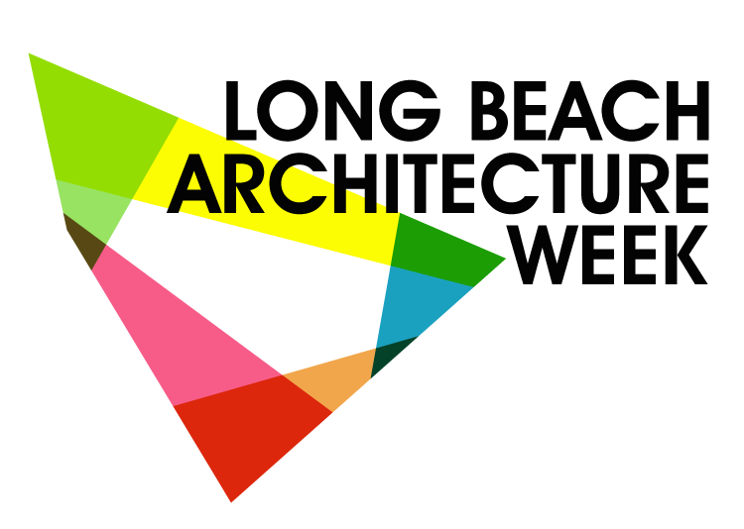

562.713.0005 cell | 562.366.3111 office
www.kahlocreative.com | www.lbhomeliving.com
140 Linden Ave. Downtown Long Beach

Connect with us: Facebook | Yelp | Linkedin

