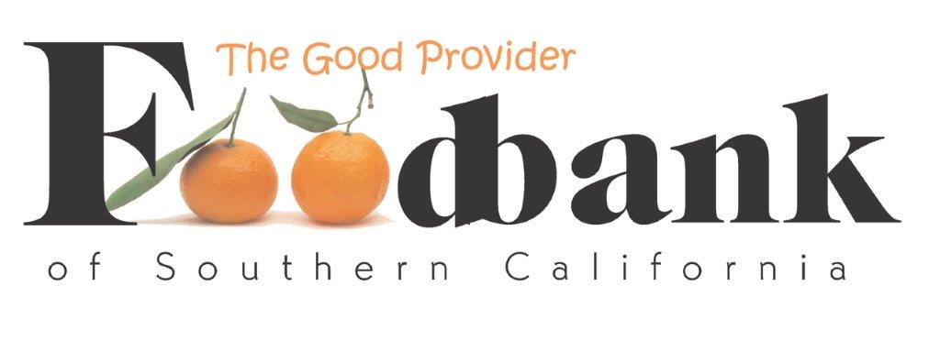

The Foodbank of Southern California

Contact:
Val Parker
vparker@thefoodbankofsocal.org
562-435-3577 x216
https://foodbankofsocal.org/
Position:
Social Media and Marketing Intern

Deadline for Application: NA

Description:
The Foodbank of Southern California is seeking an intern to assist with increasing our social media presence and implementing our comprehensive marketing strategies.

Internship Training
Working in partnership with Development Department staff, student will:
- Increase knowledge and understanding of the role of social media in building capacity in a nonprofit organization.
- Obtain real-world experience in developing and implementing a social media calendar, including creating and posting across a variety of social media platforms.
- Gain experience in maintaining consistent media image and brand.
- Increase written communication skills through developing content, writing press releases, blog-posts and reports.
- Learn how to evaluate effectiveness of social media and marketing efforts.
- Other skills as defined in partnership between supervisor and student.
Intern Roles/Responsibilities:
Duties include, but are not limited to:
- Create and post content for social media channels.
- Collect and take photographs of Foodbank events and activities, including mobile food pantries.
- Make updates to website, with approval of supervisor and CEO.
- Create a library of social media assets to supplement marketing campaigns.
- Acknowledge and thank funders and sponsors through social media.
- Create and carry-out online fundraising campaigns.
- Track social media engagement to identify high-performing ideas.
- Assist in carrying out marketing plan, raising awareness of Foodbank services and initiatives.
- Publicize volunteer recruitment and fundraising efforts.
- May assist with presentations to community and civic groups.
- Other outreach initiatives as developed in partnership between supervisor and student.

Schedule:
The Foodbank is open Monday-Friday, 7:30 a.m. -3:30 p.m. Internship schedule can be flexible, hybrid remote and in-person.

Qualifications:
- Knowledge of social media platforms.
- Experience creating engaging social media content
- Ability to take excellent, compelling photographs
- Ability to maintain consistent graphic image
- Strong writing skills.
- Ability to work independently. Organized, self-motivated, resourceful and flexible.
- Computer aptitude and Microsoft Office experience required.
- Comfortable working in an office environment. Display strong interpersonal skills.
- Enjoys meeting new people and community outreach.
- Knowledge of WordPress and website development helpful, but not required.
- Committed to the mission of The Foodbank.
How to apply:
Submit a one-page cover letter of interest, a current resume, and one professional/academic reference. To apply, please email your letter of interest, resume, and reference to Val Parker, Corporate Engagement and Volunteer Manager at vparker@foodbankofsocal.org, indicating “Internship Interest” in the subject line.

Compensation:
This is an unpaid internship. Interns will receive letter of recommendation and reference upon successful completion of internship.

This is an excellent opportunity for an organized and motivated individual to develop marketable experience in their field. This internship provides opportunities to develop job skills, professional development and networking within the nonprofit community.

