Word-initial allophones of /r/ in Ho-Chunk*

Nancy Hall Brigid Shanley
California State University Long Beach

Abstract: Ho-Chunk has one liquid phoneme, traditionally transcribed [r], and usually described as a flap or trill. We find that in archival recordings collected by Kenneth Miner in the 1970’s, a speaker sometimes produces word-initial /r/ as [l], or more rarely as a nasal. When /r/ is produced as a rhotic, it varies in manner between a tap, approximant, r-colored vowel, or a combination of manners. We did not find clearcut examples of trills. Different tokens of the same word may have different allophones of /r/, showing some level of free variation.

Keywords: Ho-Chunk, Hoocąk, rhotics, allophony

Introduction

Ho-Chunk has one liquid consonant, typically transcribed [r]. It is usually described as a trill or a tap/flap. Table 1 summarizes linguists’ impressionistic descriptions of the sound’s articulation.
Table 1: Descriptions of Ho-Chunk /r/
Source | Verbal description (verbatim)
Susman 1943 | single-flap tongue-tip trill in alveolar position
Lipkind 1945 | a single rapid flap of the tip of the tongue against the alveolar ridge
Sebeok 1947:168 | trill
Marten 1964:46 | flap [ɾ̆]… in very slow, careful speech this sometimes has a lateral quality
Danker 1985:45 | single lateralized flap of the tip of the tongue
Miner 1992:4 | dental trill
Wolff 1951:201 | initial allophone of Winnebago /r/ is [d]
White Eagle 1988:xvii (introduction by Philip LeSourd) | flap r
Helmbrecht & Lehmann 2010 | voiced alveolar tap

When a language has only one liquid phoneme, it is common for that phoneme to have both rhotic and lateral allophones (Maddieson 1984:83), and sometimes nasal or stop allophones as well. For example, Boas (1911:16-17) notes that Pawnee “contains a sound which may be heard more or less distinctly sometimes as an l, sometimes an r, sometimes as n, and again as d, which, however, without any doubt, is throughout the same sound, although modified to a certain extent by its position in the word and by surrounding sounds.”
Ho-Chunk /r/ is known to have a nasal allophone, which occurs predictably after a nasal vowel and is traditionally transcribed [ň] (Susman 1943:16, Lipkind 1945:1, Miner 1992:5, among others). An acoustic study found that [ň] varies in duration between values typical of a nasalized flap [ɾ͂] and a full nasal stop [n] (Panick 2021, Panick & Hall 2023).
There is scant mention in the literature of other phonetic variation in the realization of Ho-Chunk /r/. Susman 1943:16 does single out /r/ as sounding different in word-initial versus word-internal position, but her claim that “r seems to be clearer and sharper intervocalically” is hard to interpret in terms of phonetic features. Wolff (1951:201) claims that “the initial allophone of Winnebago /r/ is [d]”. A wordlist from Hayden 1868 also contains a few examples of initial /r/ transcribed as d, such as du-za’ for ‘wash’ (/ruʒa/) and da’-ba-ra for ‘beaver’ (/raab-ra/). However, Hayden transcribes most other initial /r/s as r, and he also transcribes some non-initial /r/s as d, so this seems more likely to reflect his inconsistent interpretation of [ɾ] rather than the allophony pattern claimed by Wolff.
Marten (1964) mentions of /r/ that ‘in very slow, careful speech this sometimes has a lateral quality’. Danker (1985) also described /r/ as ‘lateralized’, although Danker does not suggest that the lateralization varies depending on speech style.
Walker (1974:399) reports that Ho-Chunk speakers interchange [r] and [l] in English, citing an unpublished manuscript by Amelia Susman claiming that “the Winnebago substitute a l sound for the English r in pray”. Walker further reports that:

The substitution of [l] for [r] in English words as pronounced by Winnebago speakers is confirmed by Nancy O. Lurie who wrote… that “Old timey Winnebago like Blowsnake pronounced flute and fruit exactly the same way Prut.” Frances Perry… also wrote… that “when my Indian friend Flora and I write to each other we call ourselves Frora and Plances interchanging P and F and l and r, which pairs sound alike to them.”

Interchanging /r/ and /l/ in a second language is common among bilinguals whose first language has a single liquid with [r] and [l] allophones.
Researchers working with archival Ho-Chunk recordings in our lab have frequently noticed words where initial /r/ sounds like [l]. The initial impetus for the current study was to follow up on these observations and to see whether there was a pattern to the occurrence of [l] allophones. As we noticed more variation, we decided to document other allophones of /r/ as well.

Methods

We analyzed tokens drawn from 1974-75 fieldwork recordings collected by Kenneth Miner, now archived at the University of Wisconsin-Milwaukee Libraries. These recordings feature mostly elicitation of single words or short phrases. Most speech is by Lavina Thorud (Mąąxiánąžįwįga) who was born in 1912; there is also some speech by Robinson Johnson. An ongoing annotation project at CSULB (Hall et al. 2019) has isolated and transcribed around 8400 word tokens.
We extracted all tokens of words transcribed with initial /r/. This yielded 312 tokens, some of which were unusable due to poor sound quality or other problems (such as being produced directly after an English word ending in /r/). In the first pass of analysis, both authors listened and independently marked which tokens sounded [l]-like to us. Later, about a third of the tokens were examined using Praat (Boersma & Weenink 2019), in order to explore the range of phonetic variation among [r]-like tokens as well. We inspected spectrograms and waveforms to identify manner of articulation.
There are some inherent limitations in working with this corpus. The recordings were not taken in a sound-attenuated environment; some tokens are faint, and there is always some level of background noise. This can pose challenges for both acoustic analysis and auditory identification of sounds. Partly for this reason, we did not attempt to classify every token. Our focus is on documenting the range of allophones present, using the most clear-cut tokens available. We will not try to quantify the relative frequency of different rhotic allophones.

Results: types of allophones

In this section, we describe the range of allophones observed in the data. All tokens used as illustrations were produced by Lavina Thorud, except where noted.

Lateral approximant allophones

There were indeed many tokens of initial /r/ produced as [l]. 23 tokens were identified as [l] by both researchers, and there were another 51 tokens where the authors disagreed. 24 of these disagreements were in words beginning with /ru/ or /ruu/, where the first author tended to hear [l] while the second author heard a rhotic. This suggests that there is some degree of individual idiosyncrasy in the way that non-native listeners interpret this combination of Ho-Chunk sounds.
Figure 1 is an example of a clearly [l]-like production. In this example, formants begin to be visible midway through the lateral approximant. F3 is fairly high (3115 Hz), which is typical of laterals (Ladefoged & Maddieson 1996:193). The duration of this token is 140 ms.

Figure 1: beginning of /reziwaɣuuk/ ‘stick out your tongue’, with /r/ realized as a lateral approximant.
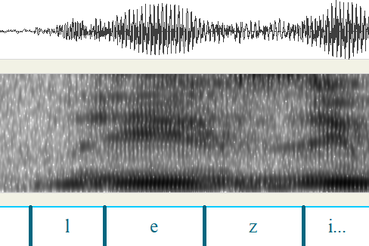

In the token below, the formant structure is visible throughout the lateral, whose duration is 87 ms. F3 is around 3540 Hz, and the space between F2 and F3 is noticeable.

Figure 2: token of /reezinąp/ 'stick out tongue', with /r/ realized as a lateral approximant
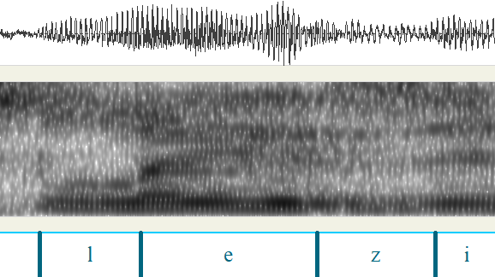

The same word could be produced with laterals in some tokens and rhotics in others, as shown below for two tokens of /reezi/ ‘tongue’. The r-like token on the left is a voiced flap with a duration of about 40 ms (although the onset is hard to identify precisely). The [l]-like token on the right is 283ms long, and sounds slightly disfluent, as if the speaker is hesitating on the sound. It again has a clear F2-F3 gap, and F3 is around 3130 Hz.

Figure 3: Two tokens of /reezi/ 'tongue', with /r/ realized as [ɾ] and [l].
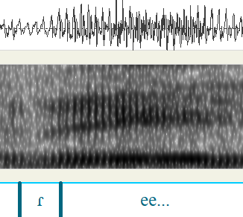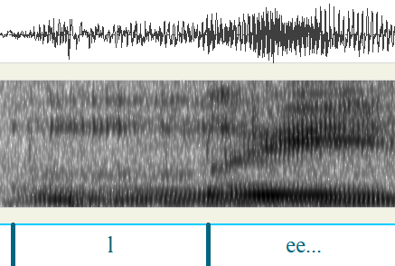

There was no obvious pattern as to what phonetic environment the [l] allophones occurred in, aside from being apparently confined to word-initial position. We found examples before all five vowel qualities, as in [laaɣo] ‘lungs’, [luʒa] ‘wash’, [liid͡ʒəɾe] ‘bend it’, [logad͡ʒikʔi̜] ‘suspenders’, and [leezi] ‘tongue’. The lack of a conditioning environment, and especially the existence of within-word variation, suggest that the [l] is a stylistic variant. As noted above, Marten (1964) associated [l] with ‘very slow, careful speech’. The elicitation sessions in these recordings fit that description; the speakers mostly produce the words slowly and in isolation so that the linguist can transcribe them.

Flap allophones

As shown in Table 1, most linguists describe Ho-Chunk /r/ as a flap, and flap realizations were indeed very common. The flap allophone is easiest to see in those cases where there is a vowel preceding it. This can happen in a phrasal context, if the preceding word ends in a vowel. It can also happen in a token produced in isolation, if the speaker produces an excrescent schwa before the occlusion, as in the example below (which was produced by the male speaker). The schwa-like vocoid before the flap is non-phonemic and not consistently present. In this token, the /r/ appears to be a non-continuant flap: the intensity dips, and there are no strong formants during the occlusion. This flap is about 44 ms long.

Figure 4: token of /reex/ 'pail', produced by male speaker, with excrescent schwa before the flap
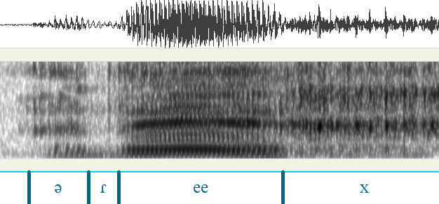

Most flap tokens, however, do not have a pre-vowel. In these cases, it is not possible to measure the duration of the flap. In the token below, for example, there is a clear point where the flap is released and the vowel begins, but there is no acoustic marker of when the flap occlusion begins.

Figure 5: beginning of /reet’ųgwaakʃąną/ 'lying laying down', showing flap with no clear onset
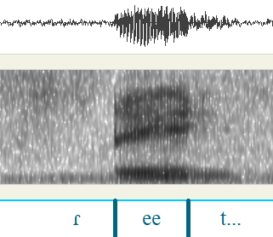

As mentioned earlier, Wolff (1951) claims that /r/ is produced as [d] word-initially. While we did not hear any of the tokens as [d], it is worth noting that the spectrogram in Figure 5 does look similar to an unaspirated stop. It could well be that some styles of producing or perceiving tokens like this could produce an impression of initial [d].

Trill allophones?

Although several sources have described Ho-Chunk /r/ as a trill, we did not find unambiguous examples of trills in the data. A trill should contain two or more rapid tongue-tip occlusions. Based on the intensity curve (shown in green), the token below could be interpreted as a two-tap trill, with a total duration of 130ms. However, it could also possibly be a flap with an excrescent pre-vowel, similar to that in Figure 4.

Figure 6: token of /raasga/ 'lighter', with possibly trilled onset. Green line = intensity
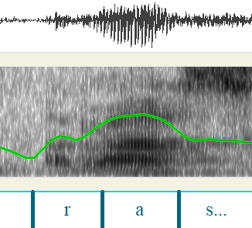

There are no clearcut examples of trills with more than 2 occlusions. The single marginal example we found is shown below. In this utterance, the speaker stops and repeats the word’s initial syllable. The first time, the /r/ appears to be an approximant, but the second time the /r/ sounds clearly trilled, with at least 3 rapid occlusions. However, given that this trill was produced in the context of a disfluency, it is not an ideal example to show the trill as a regular allophone.

Figure 7: token of /raaʃ/ 'name', stopped and re-started
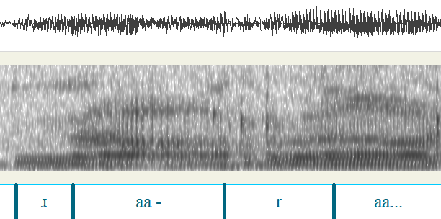

Low-intensity rhotic approximant allophones

In some cases, /r/ was produced as a low-intensity rhotic approximant (which we will transcribe [ɹ]). The token below displays a period of voicing as well as formant structure, with a duration of 107 ms. The mean F3 is 2832.

Figure 8: token of /reex/ 'pail', with rhotic approximant
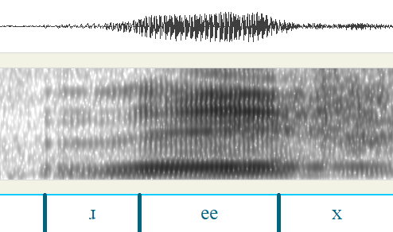

Some tokens of approximants have a period of voicing but no visible formant structure. The token below has a duration of 83 ms. It is auditorily somewhat ambiguous between [ɹ] and [l].

Figure 9: token of /reex/ 'pail', with rhotic approximant
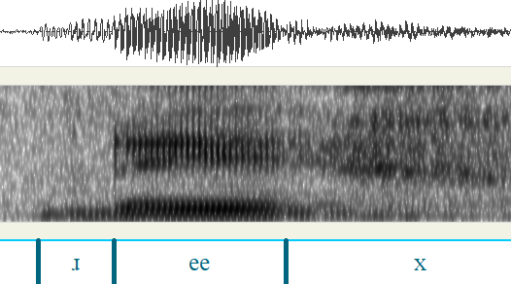

R-colored vowel allophones

While the approximant tokens above had low intensity and weak formant structure, there are other tokens that could be considered r-colored vowels. We have transcribed the /r/ in the token below as [ɚ] to distinguish it from the weaker approximants above, although its intensity is somewhat less than that of the following [a]. Its duration is 91 ms. The formants are difficult to separate, but there is a clear formant transition between the rhotic and following [a].
Figure 10: token of /raak/ 'white ash', with vocalic /r/
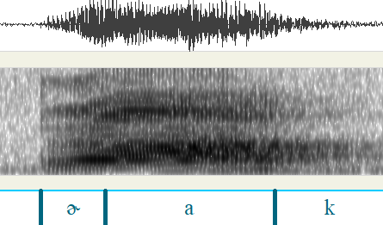

2-part articulation with r-colored vowel

In the token below, the /r/ appears to be realized with two distinct parts: a consonantal occlusion and an r-colored vowel. The consonantal portion is 78 ms and tentatively transcribed [ɹ], although it is very quiet and hard to identify auditorily. The vocalic portion is 67 ms. Its F3 begins very low (1900 Hz), which is characteristic of rhotics.

Figure 11: token of /roohą/ 'lots', with r-colored vowel.
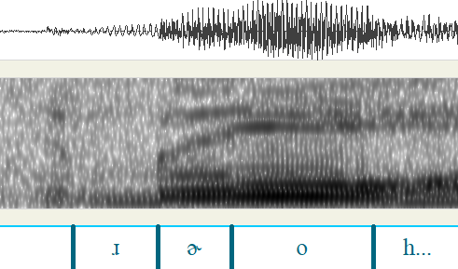

Nasal allophones

To our surprise, a few tokens sounded like nasals to one or both authors. There were 5 tokens that both authors identified as [n], and another 9 tokens with reasonably good audio quality that one author or the other identified as [n], while the other author heard an [l] or [ɹ]. An example of a token that both authors heard as [n] is shown below. The duration of the [n] is 99 ms.

Figure 12: token of /raɣakʃąwąk/ ‘you cry moving’, with apparently nasal /r/
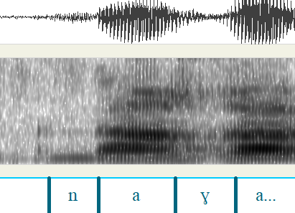

Ho-Chunk /r/ is known to become nasalized after nasal vowels, but in these cases there is no preceding nasal vowel to trigger such a change, so finding [n]s was unexpected.
We have not explored whether such examples are acoustically identical to lexical /n/.

Summary

The corpus contained examples of at least 6 allophones of /r/ in word-initial position: flap, lateral approximant, rhotic approximant, r-colored vowel, consonant plus r-colored vowel, and nasal. The flap could be produced with or without an excrescent vowel preceding.

Speaker’s metalinguistic discussion of [l] allophones

Interestingly, Miner and Thorud discuss and comment on the r/l variation during the elicitation sessions. These conversations show that Thorud was able to hear and control the variation, and that she equated the [l] allophone with English [l].
In the conversation in (1), Thorud appears to deliberately produce [l] as an alternative realization of /r/. Both Thorud and Miner agree that there are two ways to produce the same word.

(1) Miner: What do you call the Chippewa Indians?
Thorud: [ɹeegatʃi], [ɾeegatʃi] … [leegatʃi], you could put it [leegatʃi] on there
Miner: See, that’s what I’m wondering. There’s two choices on that first sound.
Thorud: Yeah. It is.

Another case in which both Miner and Thorud acknowledge the existence of two variants is:

(2) Miner: How would you say ‘tongue’?
Thorud: [leezi] ... lazy (laughs) ... but did the pronounces ... the pronunciation is... [leezi]
Miner: If I pronounced it [ɾeezi], would it be OK...
Thorud: Yeah... [ɾeezi], you could say [ɾeezi] too.

Thorud is apparently amused by the similarity of Ho-Chunk [leezi] and English lazy. This is one of at least three times that she compares a Ho-Chunk [l] variant with an English word beginning with [l].
When discussing the morphology of /reegatʃi/ ‘Chippewa’, she compares the sequence [leeg] to English lake.

(3) Miner: Now that word for Chippewa...
Thorud: [ɾeegatʃi]
Miner: Yeah. Does that have a meaning?
Thorud: (under breath) [leɾeeeee ga tʃi]
Miner: Mean anything else other than Chippewa?
Thorud: Just the [tʃi] part is a house, but that wouldn’t, wouldn’t come near it… I don’t know why they call those Chippewa [leegatʃi] unless they… lake-atʃi but then the lake is in English, so that wouldn’t be for that either. Just uh, they just call them [leegatʃi].

Similarly, when discussing /raak/ ‘white ash tree’, Thorud jokingly compares the [l] variant to the English word log.

(4) Miner: And the word they have here for the other one, the white ash, is something like [ɾook]
Thorud: [ɚaak]. Sure.
Miner: [ɾaak]?
Thorud: [laak]. Just...you can just even put log down for that (laughs)
Miner: Hmm?
Thorud: You can even put log down for that. (inaudible sentence). Yeah. [laak]

Thorud’s ability to hear and control the r / l variants is somewhat unusual for allophonic free variation, which cross-linguistically is usually below the speaker’s level of awareness. This could relate to her being bilingual in English, which has a phonemic r / l contrast.

Discussion

In these recordings, Lavina Thorud often produces word-initial /r/ as [l], confirming a little-noticed observation by Marten (1964). The rhotic realizations of /r/ also have several variants, including a tap, approximant, rhotic vowel, or combinations of these. We did not find clear-cut examples of trills, contrary to previous descriptions. We observed occasional realizations of /r/ as [n], which have not to our knowledge been previously reported in this context. [n] is known to regularly occur as an allophone of /r/ following nasal vowels, but in these cases there was no preceding vowel. We did not find examples of the [d] allophones reported by Wolff (1951).
The various allophones appear to be in free variation, as the same word is often produced multiple ways in close succession. This supports Marten’s claim that the [l] is a stylistic variant, rather than a phonologically conditioned allophone.
The finding that /r/ has [n]-like realizations (in a non-nasal context) may shed light on the diachronic and synchronic interplay of these sounds in Ho-Chunk. Historically, /r/ became /n/ before nasal vowels, and as noted in Section 1, there is a synchronic alternation in which /r/ becomes [ň] after nasal vowels as well. If /r/ is sporadically nasalized even not in a nasal context, this may shed light on why it has been particularly prone to undergo nasal assimilation.
The occurrence of [l] and [n] allophones in word-initial position could relate to a cross-linguistic pattern that Labrune (2021) calls ‘word-initial rhotic avoidance’. Labrune claims that many languages avoid rhotics in word-initial position through various means. In some languages, rhotic phonemes are banned in initial position, in others they are statistically dispreferred. In other languages, the rhotic has lateral or nasal allophones in word-initial position. Labrune cites Warao, where the flap is realized as [d] word-initially (Romero-Figueroa 1997), and Wichita, where /ɾ/ is nasalized word-initially (Garvin 1950). Another possible example is Chaha, where /r/ becomes [n] word-initially: [nik’im] ‘pick!’ versus [jirak’im] ‘he picks’ (Banksira 1997, cited in Rose 2000).
The findings presented here should be seen as preliminary and limited. They are based mostly on a single speaker, and the uneven recording quality did not allow us to fully explore the phonetics of all the liquid allophones. Nevertheless, it is clear that Ho-Chunk has more allophones of /r/ than have been previously described, and we hope that this study will help linguists to recognize these and other variants in other data sources.

References

Banksira, Degif Petros. 1997. The sound system of Chaha. PhD dissertation, Université du Québec à MontréalBoas, Franz. 1911. Handbook of American Indian languages, part 1. Government Printing Office: Washington.
Boersma, Paul & David Weenink. 2019. Praat: doing phonetics by computer [Computer program].
Danker, Kathleen. 1985. The Winnebago narratives of Felix White, Sr.: Style, structure and function. PhD thesis, University of Nebraska – Lincoln.
Garvin, Paul L. 1950. Wichita I: phonemics. International Journal of American Linguistics 16(4). 179-184.
Hall, Nancy, Andie Niederecker, Elica Sue, & Irene Orellana. 2019. Annotating Archival Recordings of Hocank (Winnebago). In Katherine Hout, Anna Mai, Adam McCollum, Sharon Rose, & Matthew Zaslansky (ed.s) Proceedings of the 2018 Annual Meeting on Phonology
Hayden, Ferdinand Vandeveer. 1868. Brief notes on the Pawnee, Winnebago, and Omaha languages. Proceedings of the American Philosophical Society 10(78), 389-421.
Helmbrecht, Johannes, and Christian Lehmann (ed.s) 2010. Hocąk teaching materials volume 1: Elements of grammar/learner’s dictionary. Albany, NY (USA): State University of New York Press.
Labrune, Laurence. 2021. Word-initial rhotic avoidance: a typological survey. Glossa: a journal of general linguistics 6(1).
Ladefoged, Peter & Ian Maddieson. 1996. The sounds of the world’s languages. Malden, MA (USA): Blackwell Publishing.
Lipkind, William. 1945. Winnebago Grammar. New York: King's Crown Press.
Maddieson, Ian. 1984. Patterns of sounds. Cambridge: Cambridge University Press.
Marten, Anita. 1964. The morphophonemics of the Winnebago verbal. PhD dissertation, University of Wisconsin-Madison.
Miner, Kenneth. 1992. Winnebago Grammar [unpublished manuscript]
Panick, Sean Davis. 2021. R-Nasalization in Hoocąk: a Diachronic and Synchronic Perspective. MA thesis, California State University, Long Beach.
Panick, Sean, and Nancy Hall. 2023. The evolution of flap-nasalization in Hoocąk. Linguistics Vanguard 8(5), 703-713.
Romero-Figueroa, Andrès. 1997. A reference grammar of Warao. Lincom Studies in Native American Linguistics (6). München: Lincom Europa.
Rose, Sharon. 2000. Epenthesis positioning and syllable contact in Chaha. Phonology 17(3), 397-425.
Sebeok, Thomas A. 1947. Two Winnebago Texts. International Journal of American Linguistics, 13(3), 167-170.
Susman, Amelia. 1943. The Accentual System of Winnebago. PhD dissertation, Columbia University.
Walker, Willard. 1974. The Winnebago syllabary and the generative model. Anthropological Linguistics 16(8), 393-414.
White Eagle, Josephine P. 1988. A lexical study of Winnebago. No. 26. Lexicon Project, Center for Cognitive Science, MIT
Wolff, Hans. 1951. Comparative Siouan IV. International Journal of American Linguistics 17(4), 197-204.

* This project was supported by the Undergraduate Research Opportunity Program (UROP) at California State University Long Beach.
To be clear, we did not examine medial /r/ ourselves, but Sean Panick conducted an extensive study of word-medial /r/ using the same corpus, and did not encounter any cases of [l] allophones in that position (Panick 2021, Panick & Hall 2023). /r/ does not occur word-finally in Ho-Chunk.

