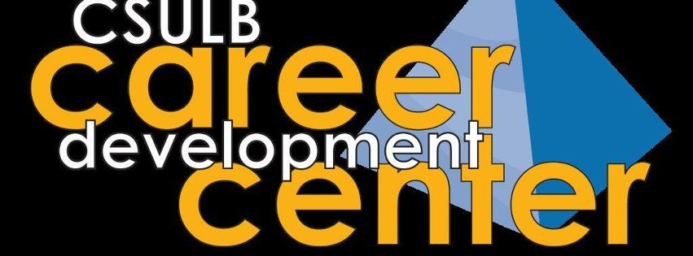
What can you do with a Political Science degree?
Do you want to learn more about the career and education options you have post-graduation?
Need more information about on-campus resources to help craft your resume and build your interview skills? Then this is the workshop for you!
Carol Brown-Elston, Career Counselor from CSULB’s Career Development Center, will be conducting this special workshop just for political science majors. Students of all class levels are welcome.

When: Wednesday, April 15, 2015
Time: 12:30-1:30pm

To RSVP please contact Elizabeth Galvan (562) 985-4704 or by email at elizabeth.galvan@csulb.edu or stop by the main department office SPA-257

