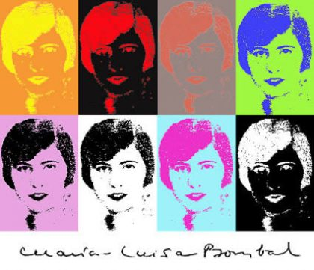

Lucía Guerra  is  professor of Latin American Literature at the University of California, Irvine. As a critic, she specializes in Critical Theory, Gender Studies, and Creative Writing. Her article entitled "*Cutural Identity and the Dilemma of Self in Latin American Women's Literature*" won the Plural Essay Award in 1987. Her book *La mujer fragmentada: Historias de un signo*was awarded the Casa de las Américas Prize in 1994. As a fiction writer, Lucía Guerra intends to give voice to women's silenced experiences; in her writing she denounces social subordination and she explores the subversive power of female eroticism.

* Sponsors: Spanish Club, Romance, German and Russian Lang. and Lit.
* & Latin American Studies

CSULB I RGRLL, Latin American Studies & the Spanish Club

*presents*

LUCIA GUERRA-CUNNINGHAM

UNIVERSITY OF CALIFORNIA, IRVINE

**CASA DE LAS AMERICAS PRIZE, 1994**

# “Maria Luisa Bombal: Cuerpo, escritura y otras tramas culturales"

**APRIL 21, 5:30-7:30 PM, ANATOL CENTER**



Contact: Dr. Alicia del Campo

[aliciadel@gmail.com](mailto:aliciadel@gmail.com)

Dr. Rita Palacios rpalacio@csulb.edu