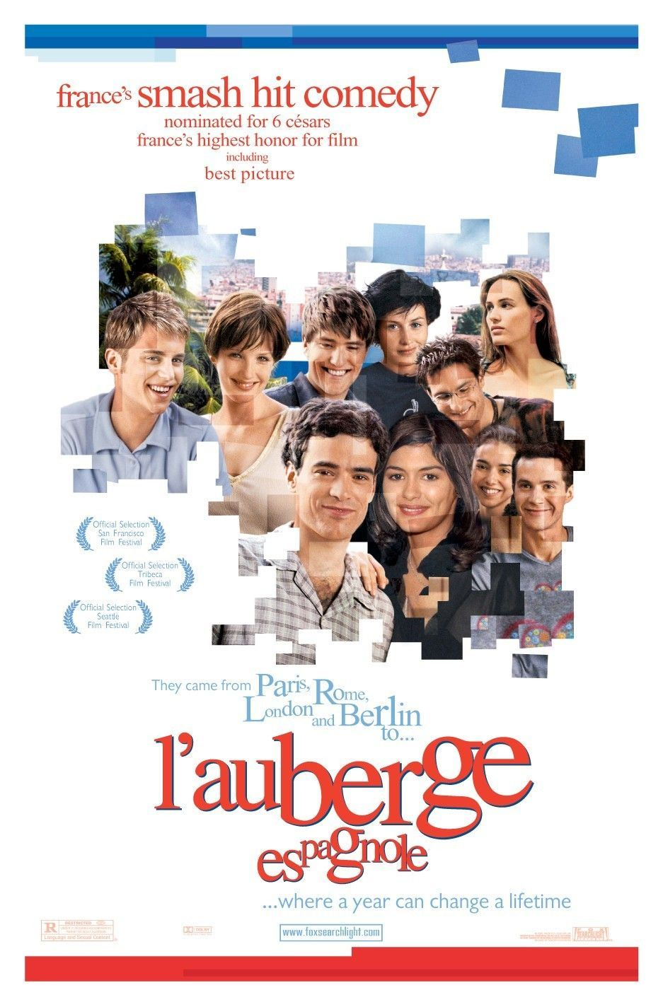

WHEN: Wednesday 9/19/2012 at 5pm

WHERE: MM 200

(MMC next to Library)

TIME: 5:00 PM

**JOIN THE FRENCH CLUB FOR**

**A SCREENING OF**

**L’AUBERGE ESPAGNOLE**