Draft CLA Faculty Council Minutes, December 14, 2016

Attendance:

Theresa Gregor, Gabriel Estrada, Jennifer Asenas, Jeff Blutinger, Michael Ahland, Ian Mitchell-Smith, Linna Li, Angela Hawk, Yutian (Kate) Chen, Malcolm Finney, Kimberly Walters, Barbara LeMaster, Chris Karajdov, Lynda McCrosky, Soumitro Sen, Marcy Lascano, Justin Gomer, Elizabeth Dahab, Edith Morris-Vasquez, Craig Stone, Rene H. Trevino, M., Karla Juarez, Cortez, Wanette Reynolds, Jessica Russell, Alexandra Jaffe, Eileen Klink, Dean Toji, James Miles, Christine El Ouardani, Rich Haesly, C.J. Murphy, Lori Baralt,

A. Call to order by Misty Jaffe, 3:36

B. Approval of Agenda, unanimous

C. Approval of minutes from November meeting, unanimous

D. Chair’s Report: The Associate Dean’s Search Committee has met and is anticipating pool approval soon. Thanks to Ilan Mitchell-Smith, Keith Claybrook, Rene Trevino for organizing first Inclusive Excellence and High Impact teaching workshop. Edith Morris-Vasquez (Chicana/o Latina/o studies) presented Centering the Autism Spectrum in 1st Year Composition with 1st Generation Students: Toward Neurodiverse Teaching Praxis and Katherine McLoone (Comp Lit) spoke about Accessing Disability in the Classroom: Disability as a Course Topic, as a Lived Experience for Students, and Alternative Teaching Modalities in Online Courses. This panel was very well attended and received and generated a lot of discussion. Plans are to archive materials.

E. Dean’s Report: The move of the Dean’s office provided additional Faculty Office space for the college and several departments in CLA will befit in new faculty office space. The old Dean’s space will soon become the new home of the CHLS Department. The move will take place over the winter break and other departments in CLA will be moving into the CHLS office space.

F. Graduation 2025 Faculty Teams (Associate Dean Beth Manke)

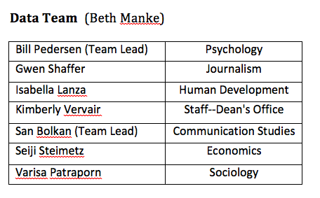 | Data Team  With the help of new software that will benefit these investigations, and the Data Team will look into why 20% of our students leave during the first year:

2. Curriculum Team
The initial focus will be to work on interdisciplinary minors to help students learn about departments that they are unfamiliar with and variable unit courses that are skills based to enhance the career readiness of our students. On-line courses may or may not be addressed by this team.

3. Career Readiness Team Report (Beth Manke)
Building upon the internship proposal to enhance the CLA internship opportunities.

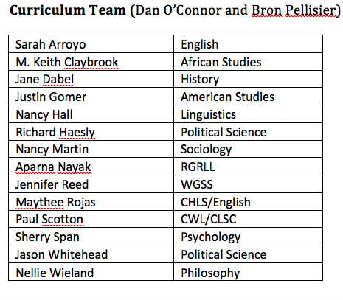 | 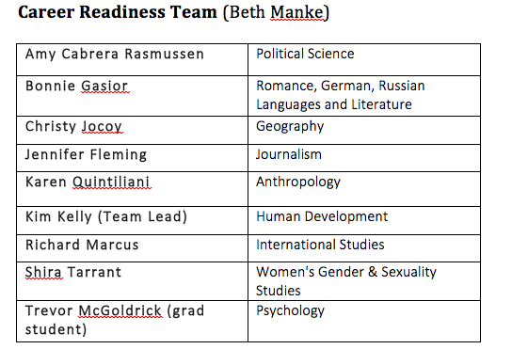

G. Budget (Dean Wallace)
GAP funding for CLA will be one million less than last year. Six million is the usual CLA budget and we have been allocated five million for this year. To address this shortfall CLA will need to cancel courses in the Spring of 2017. The primary focus will be on canceling low enrolled courses and canceling courses in Departments which are offering more courses than they offered last Spring and that do not have enrollments to justify the increase in course offerings. The hope is to save at least ¼ of a million dollars by canceling courses and having the remainder of the shortfall come from other areas in the college.
Question from the floor:
Are there any possible ways that we would acquire more funding for next semester?
Dean’s Response
A new tenure-track line costs equal to six courses taught by lecturers and last year CLA was the recipient of the most tenure track lines at CSULB. The current situation is that our overall enrollment has not increased and so will need to teach fewer courses this Spring Semester.
Question from the floor: about the efficiency of On-Line Courses and other factors impacting our budget.
Dean’s Response: San Jose State experimented with on-line courses and that was not effective or “efficient”. Our approach is to move slowly and to design, monitor and offer courses targeted to students who traditionally do well with on-line courses.

30% of faculty raises are currently covered by temporary funding that may or may not continue to be funded in the future. If this is not funded by the CSU on a permanent basis, this may also impact our budget next year.

Question about Interdisciplinary Minors
Our current Interdisciplinary Minors have a home in a Department or Program and the College would like to develop a structure for Interdisciplinary Minors that would be College-wide and fulfill the duties that departments and programs do to oversee interdisciplinary minors.

The following motion, proposed by Barbara Le Master, was adopted unanimously:

- Motion to request that the Dean’s office consult with the Faculty Council with regard to budget priorities and share data related to the projected budget shortfall and use the CLA Budget Committee to do so.

Misty will request a report and update from Terie Bostic for our next meeting to provide details about the CLA budget.

H. Scholarly Intersections Guidelines: revisions to guidelines to the Scholarly Intersections award process were presented and voted as follows:

Item 1: Timing, No Change
Keep current deadline of the 4th week of the semester but announce the opportunity in late August and again in September in order to facilitate planning. Spring call will be contingent on having funds (unanimously approved)
Item 2 : Participation
Limit individual faculty members to participate in only two proposals. (unanimously approved)
Departments can cosponsor (financially or otherwise) any number of proposals.(unanimously approved)
Encourage new/junior faculty and first-time organizers to apply and give them special consideration (approved with 2 no votes)
Require applicants to indicate if they have been funded in the past and provide details.
Item 3 Budget (approved unanimously)
Impose a strict $1000 limit on any one event
Limit hospitality to $100 per event. Limit hotel costs to the lowest rates at local hotels with which the University has a contractual arrangement, Limit honoraria to no more than $300 per person and no more than $600 per event.
Item 4: Membership of Committee (approved unanimously)
  - 5 faculty members + one member of Executive committee
  - 2 year term
  - Elected by Faculty Council
  - no more than 2 members from any department

I. Graduation 2025 Initiative follow-up: Discussion of formation of FC Ad Hoc Committee for Curricular Innovation
  - Liaison with Faculty Team and EPCC
  - Align with Strategic Plan
  - Make recommendations to EPCC regarding process/transparency/equity, curriculum priorities and college-wide benefits/impact
  - Serve as equivalent of Dept Curr Cmte for curriculum with no home department
  - Develop procedures and charge for permanent committee (Constitutional Amendment)

Moved to adjourn at 5:03, Misty Jaffe, Second, Theresa Gregor

Submitted by Craig Stone

