CLA RTP Policy (proposed Appendix: Continuum of Scholarship)
CLA Equity Task Force, Team 4: Raven Pfister & Emily Berquist Soule, co-leads
Equity Task Force Members: Linna Li, Jacqueline Lyon, & Varisa Patraporn

Appendix A: Continuum of Scholarship Matrix

PURPOSE

Consistent with the University’s Retention, Tenure, and Promotion (RTP) policies, the College of Liberal Arts (CLA) recognizes diverse forms of scholarship. As stated in the CLA RTP policy, candidates may make contributions to the scholarship of discovery, the scholarship of integration, the scholarship of application or engagement*, and/or the scholarship of teaching and learning. Contributions may be in one area or across multiple areas of the continuum of scholarship. Scholarly contributions to any area(s) are valued equally by the CLA.

As these areas of scholarship and the associated terminology may be unfamiliar to faculty, the matrix below was developed to provide an additional source of support for candidates undergoing the RTP process and/or the committees tasked with evaluating them. The following descriptions and examples are not intended to be exclusive or exhaustive. Disciplines and departments will vary. Therefore, this matrix is provided as a guide, not a checklist.

*Note: Per Boyer's (1990) original classification, the matrix below presents the scholarship of application and the scholarship of engagement separately. Additional resources on the scholarship of engagement can be found in Appendix A.1 at the conclusion of this document.

Continuum of Scholarship Matrix (adapted from Worcester Polytechnic Institute, 2019-2020)

Scholarship Area & Brief Description | Products/Artifacts (work created by the candidate) | Evidence of Quality (evaluation of work created by the candidate) | Impact & Leadership (influence of work on others or the field)
DISCOVERY  Creation of new disciplinary (or interdisciplinary) knowledge through creative/critical thought, research, and testing that is shared with others  Example: empirical research | - Publications (articles, books, policy papers, etc.; may be based on theses, dissertations, etc.).  - Presentations (conferences, round tables, webinars/virtual).  - Inventions and patents.  - Grant proposals.  - Creative products (e.g., exhibits and performances).  - Original creations in writing or multimedia, artistic works, or new technologies.  - Publicly available electronic resources (e.g., software, websites, databases, etc.). | - Peer-review and acceptance of artifacts.  - Journal impact factors (if appropriate).  - Citation index (if appropriate).  - Research productivity indices.  - Successfully funded competitive grants.  - Reviews of published work (e.g., books).  - Awards and honors. | - Citations of work by others.  - Designation as an expert: guest lecturer, invited speaker, keynote address, scholarship reviewer (grants, papers, books, conferences), tenure/promotion external reviewer, expert witness.  - Featured performances at international, national, or regional venues.  - Number of views, shares, likes for online dissemination of scholarship (e.g., podcasts, videos).  - Editorship of high-quality disciplinary and interdisciplinary journals.  - Leadership in professional organizations and duration of such leadership.
INTEGRATION  Critical evaluation, synthesis, analysis, integration, or interpretation of disciplinary (or interdisciplinary) research or creative work produced by others  Example: literature review, meta-analysis | - Reflective essays and reviews.  - Translations.  - Popular publications.  - Syntheses of the literature (e.g., literature reviews, meta-analyses, theory building papers).  - Products/artifacts typical of discovery and application and practice. | - Reviews in newspapers for a creative work.  - Book talks at universities and to public audiences.  - Examples where colleagues from inside or outside CSULB have used the scholarship.  - Evidence typical of discovery, application and practice, teaching and learning, and engagement. | - Evidence that others or the field have been influenced by the outcome (e.g., adoption, changes in perspectives in field; sharing materials).  - Public venues to share scholarship with non- specialist/non-academic audiences.  - Impact/leadership typical of discovery, application and practice, teaching and learning, and engagement.

Scholarship Area & Brief Description | Products/Artifacts (work created by the candidate) | Evidence of Quality (evaluation of work created by the candidate) | Impact & Leadership (influence of work on others or the field)
APPLICATION AND PRACTICE  Use of a scholar’s disciplinary or interdisciplinary knowledge to address important individual, institutional, and societal problems  Example: development of a technology | - Translational research.  - Commercialization.  - Start-ups.  - Technology transfer.  - Technology development (e.g., assistive, learning).  - Applied research supported by industry or government (e.g., policy adaptations, program recommendations, industry/government funding).  - Products/artifacts typical of discovery and engagement. | - Products shared with stakeholders and open to review and critique by stakeholders and by peers.  - Evidence typical of discovery, integration, teaching and learning, and engagement. | - Consulting related to work.  - Approaches, methods, and tools, adopted and assessed by an end user(s) with positive results.  - Impact/leadership typical of discovery, integration, teaching and learning, and engagement.
ENGAGEMENT  Collaborative partnerships with communities for the mutually beneficial exchange of knowledge and resources and/or transformation of communities through shared projects and research  Example: Community-based programming (e.g., health assessments) | - Community-based programs that enhance curriculum, teaching and learning.  - Educational or public outreach programs.  - Partnerships with communities beyond campus to address critical societal issues, prepare educated citizens, or contribute to the public good.  - Publication in public scholarship venues (e.g., videos, blogs, open access journals, digital humanities products, etc.).  - Products/artifacts typical of discovery, integration, application and practice, teaching and learning. | - Works that benefit the external community, are visible and shared with stakeholders, and are open to review and critique by community stakeholders and by peers.  - Sustained, mutually beneficial relationships with communities and organizations.  - Evidence typical of discovery, integration, application and practice, and teaching and learning. | - Bringing to light and/or improving economic, social or environmental conditions of a community, region, agency, industry, or other sector.  - Generation of major gifts to endow a program.  - Citations or adoption of work by communities.  - Impact/leadership typical of discovery, integration, application and practice, and teaching and learning.

Scholarship Area & Brief Description | Products/Artifacts (work created by the candidate) | Evidence of Quality (evaluation of work created by the candidate) | Impact & Leadership (influence of work on others or the field)
TEACHING AND LEARNING  Development and improvement of pedagogical practices that are shared with others  Example: development and assessment of teaching/learning practices | - Assessment and evaluation of teaching and student learning (e.g., teaching portfolio, professional development of other teachers).  - Development and dissemination of instructional materials used by others to improve pedagogy and learning (e.g., syllabi, notes, manuals, books etc.).  - Products/artifacts typical of discovery, integration, application and practice (e.g., learning technologies). | - Products shared with other teachers at other universities or educational institutions.  - External reviews of pedagogical practices.  - Public dissemination (e.g., podcast, summative blogpost, public science communication campaign, etc.).  - Evidence typical of discovery, application and practice, and engagement. | - Wide adoption of materials and methods by others (e.g., downloads, likes, shares).  - Popular (3rd party) articles.  - Social media hits and followers.  - Impact/leadership typical of discovery, application. and practice, and engagement.

CLA RTP Policy (proposed Appendix for evaluation of Scholarship of Engagement)
CLA Equity Task Force, Team 4: Raven Pfister & Emily Berquist Soule, co-leads
Equity Task Force Members: Linna Li, Jacqueline Lyon, & Varisa Patraporn

Appendix A.1: Scholarship of Engagement

PURPOSE

Consistent with the University’s Retention, Tenure, and Promotion (RTP) policies, the College of Liberal Arts recognizes Scholarship of Engagement (SoE) as form of research, scholarly, and creative activity (RSCA) that meets department, College, and University expectations for the scholarly output of faculty, including that necessary for the RTP process. It is a fundamental part of the university mission that bridges research, pedagogy, and community service in an organic way.

The framework below includes a definition of Scholarship of Engagement as well as evaluation criteria that can be utilized both by candidates to prepare their RTP files, and evaluation committees to assess this RSCA more accurately and equitably, according to applicable Department, College, and University standards.

SCHOLARSHIP OF ENGAGEMENT: DEFINITION

This document uses the Scholarship of Engagement definition proposed by The American Council on Education in 2022, which defines this work as:

“Collaboration between institutions of higher education and their larger communities (local, regional/state, national, global) for the mutually beneficial exchange of knowledge and resources in a context of partnership and reciprocity.”

The purpose of SoE work is not only “to enrich scholarship, research, and creative activity and to enhance curriculum, teaching, and learning,” but also “to prepare educated, engaged citizens; strengthen democratic values and civic responsibility; address critical societal issues; and contribute to the public good” (American Council on Education, 2022). Additionally, SoE work should empower people in ways that result in desired outcomes, informed decisions, and/or improved quality of life. This emphasis on balancing the interests of the university’s knowledge-production goals and the interests of communities pursuing the public good aligns with Ernest Boyer’s (1990; 1996; 2016) classic works on SoE.

Boyer underscores that Scholarship of Engagement entails an epistemological shift in the locus of knowledge production, from one driven primarily or exclusively by the interests of university faculty, to one driven by shared interests with the communities with whom the university is collaborating. The aims and methods of SoE knowledge creation and the products emerging from this work are concretely situated within this collaborative relationship with communities seeking to address a specific issue or issues. So while some SoE work may result in peer-reviewed scholarly publications, many SoE products are designed to support communities in pursuing the public good and may not be geared toward an academic audience. Such products must be evaluated in relationship to the concrete processes that generated them, not according to the criteria of peer-reviewed scholarly journals.

Faculty Roles

In a comprehensive review of Scholarship of Engagement literature over the past 25 years, Beaulieu et al. (2018) found that SoE involves building trusting relationships with community members, institutions, organizations, and other interest groups. It entails “participatory practices, reciprocity, co-construction, democratic practices, shared authority, and shared resources.” Faculty roles can vary widely in these collaborative relationships.

For example, faculty can use their expertise to co-design and guide research activities (e.g., literature reviews, instrument construction, data gathering and analysis, reports, etc.), including training community members on how to conduct research. In other cases, they may provide support for community leadership development (e.g., civic leadership); organizational capacity building; community organizing and planning; or assist in designing and facilitating multi-stakeholder strategic planning processes (among other types of projects.) Scholarship of Engagement projects can be supported singularly by one faculty member and/or supported by multi-disciplinary or cross-disciplinary teams. They can also include community partners outside of academia who make central contributions to and provide vital feedback on the work throughout the process.

Range of Products

Products emerging from Scholarship of Engagement are differentiated depending on the aims and concrete conditions affecting the collaborative work. Products can include, but are not limited to, survey questionnaires; interview schedules; focus group questions; process design; community needs assessments; community asset inventories; curriculum and training manuals; program evaluation reports; research briefs and reports; grant proposals; action plans; strategic plans; policy memos or briefs; prototyping models; popular education materials and other products relevant to the social change process. Note that SoE work is distinguished from industrial projects, community volunteer work, or the good citizenship responsibilities of academia. In general, SoE is purpose-driven work for a specific community or group.

Collective Authorship and Peer Review

Because faculty engaged in Scholarship of Engagement actively co-produce knowledge(s) with community stakeholders in a collaborative process, authoring certain SoE products is a collaborative process. By nature, collaboration contains internal and external mechanisms of peer review by community members and collaborators that occur in real-time and shape the faculty member’s contributions. There are a multitude of ways internal peer review can be accomplished during work on an SoE project, and it is impossible to articulate and list them all. For example, internal forms of peer review can be provided by task force members participating in a project. Community members who offer feedback on a proposed curriculum or policy proposal to ensure consistency with their aims and/or congruency with their cultural perspective(s) are providing another form of peer review. External entities such as funding and government agencies provide another level of peer review in this process
(see CLA RTP Policy 2.2.3.1a-f for additional examples).

SCHOLARSHIP OF ENGAGEMENT: EVALUATION CRITERIA

Given the wide range of RSCA products that can emerge from Scholarship of Engagement projects, this policy acknowledges it the choice of the candidate undergoing the RTP process whether they want this work to be evaluated under RSCA, teaching, or service. For SoE work being evaluated as RSCA, candidates should provide a record of scholarly engagement-related publications and evidence of national/international visibility. It may include innovation and creativity when developing and delivering programs, products, and services that promote informed decisions and/or improve quality of life. Importantly, the quantity, strength, and impact of SoE work on stakeholders can take a variety of forms, including, but not limited to: the enactment of related legislation, adoption of innovations, and/or widespread changes in professional practice; publications that translate research for practitioners, entrepreneurs, business/industry leaders, and/or policy makers; and connecting research with the appropriate markets (commercialization). Engagement scholarship integrates faculty roles of learning and discovery, so candidates are encouraged to cross-list their scholarship/engagement activities throughout their RTP documents. Engaged scholarship may serve the university’s mission by working with government, schools, non-profits, business, and/or industry. These are just examples and are not intended to restrict the many possible indicators.

The instrument below is designed for preparing and reviewing files that include Scholarship of Engagement as RSCA. It may be used both in evaluating SoE for RSCA criteria (including RSCA funding), and for RTP criteria. Candidates and evaluators may emphasize the following general goals of this work (criteria) and evaluate whether RTP standards have been met by demonstrating that the scholar has provided evidence (indicators) that highlight the impact of this work.

Scholarship of Engagement Evaluative Instrument (adapted from the University of Minnesota’s policy for the Assessment of Community-Minded Scholarship, 2018)

CRITERIA | INDICATORS
- Goals for Academic and Community Change.  Candidates should clearly define the aims, focus, and purpose of their work. | - a concise articulation of the broad aims of the work; how it contributes to the candidate's discipline/field; and a clear description of how this RSCA resulted in the improvement of service delivery and/or policy change to benefit external/community partners  - a coherent statement detailing the program of RSCA and its objectives  - a statement of realistic, executable, impactful goals and objectives for the RSCA  - clear description of the RSCA's goals for teaching and student learning  - a statement outlining how this RSCA contributes to major intellectual questions in the field and how the work is of major concern and/or impact for community/external partners
- Sufficient Grounding in Content Area and Community Groundwork.  Candidates should clearly define their own preparation to undertake this work; indicate their knowledge of prior and ongoing developments in the area; and display knowledge of how this work affects their community partners. | - description of how the candidate built, developed, and maintains essential relationships with the community (and when possible, provide relevant evidence)  - demonstration of having met the disciplinary standard for high-quality partnership and collaborative work  - description of the candidate's skills that were/are essential to the partnership  - detailing of any related skills or professional development trainings undertaken by the candidate that enhanced the Scholarship of Engagement  - explanation of how the RSCA is situated compared to existing products produced by or for community partners
- Methodology Centered in Academic Research Methods and Community Partnership Goals/Needs.  Academic rigor can be demonstrated through research design, data collection, data analysis, and reports of results. Community-engaged approaches maintain, and can enhance, academic rigor. | - collaborative work with community partners that generates, refines, or validates a research question  - collaborative work with community partners that advances or alters the scholar's methodologies; the way they collect/refine/analyze/share data; and or the recruitment of community and/or study partners  - articulation of methodologies that are appropriate to the nature of the engaged RSCA being undertaken  - indication of any modifications to research questions, approaches, or methodologies in response to community feedback  - development of policy recommendations or documents, based on RSCA findings, in collaboration with community partners  - enhancing course curriculum by including real-time feedback and information gathered from community members, when appropriate  - deepening student engagement and learning outcomes by involving community experts in course conceptualization, design, and execution, when appropriate  - building on community partnerships/expertise and student feedback to revise curriculum, when appropriate  - building on and sharing study findings through community organizations, partnerships, and policy making venues
- Demonstrating Impact on the Discipline/Field and the Community.  Academic research methods can be demonstrated through articulating the benefits the RSCA brought to the community in question. Academic research methods can also be demonstrated through assessment of the knowledge created, within the field/discipline, and in the community. | - meeting or exceeding intended goals and aims with the work; or changing the scope and approach of the project to better meet revised goals and aims  - contributing to disciplinary knowledge through publication in peer-reviewed academic journals, or in scholarly monographs  - benefitting the community partner through contributions they deem valuable  - demonstrating achieved progress towards greater equity and/or social justice, in order to benefit the public good  - applications for funding, as pertains to research, community partners, or general program implementation  - indicating how the collaborative work has resulted in change in how community partners design and implement programs, goals, and outcome measures  - contributing to the discipline by enhancing focus on issues that are central to the community partners  - identifying and elaborating new venues for further research, exploration, and/or community collaboration  - enhancing student capacity to engage in leadership roles in the community or on campus
- Effectively Communicating to Community and Scholarly Audiences.  Scholars will communicate effectively to academic and/or community audiences. Scholars will also subject their ideas to peer review, whether by scholars or practitioners in the respective field, or by community members. | - disseminating study findings to appropriate academic and public audiences aligned with the university's mission  - publishing study findings or innovations in peer-reviewed academic journals, practitioner publications including magazines, or the journals of professional societies  - using appropriate means of distribution to reach community stakeholders in an accessible, understandable fashion, i.e., disseminating findings in media with which community partners are often engaged; or producing documents aimed for legislators, service providers, and/or policy makers who affect the community in question  - using collaborative community partnerships to communicate outcomes of this RSCA
- Reflecting on How to Improve the Methodologies of Scholarship of Engagement.  Scholars will provide evidence of how they have engaged in reflective critique to improve the methodologies and outcomes of their collaborative work. | - critically evaluating the work using appropriate evidence  - seeking critical feedback from community members and implementing that feedback to change and improve research design  - altering research projects in response to feedback provided by community partners  - participating in dialogue related to the work at the local, state, national, or international level
- Personal Contribution to Collaborative Leadership.  Scholars will provide evidence of how they and their work have earned a reputation for academic rigor, scholarly importance, and/or community benefit. | - describing how the work undertaken has been recognized, utilized, or built upon by community stakeholders, experts/practitioners/professionals, and/or other academics  - providing comments or reviews from academic and/or non-academic colleagues, community peers, or recognized experts. These comments/reviews can be solicited or unsolicited, formal or informal, anonymous or tied directly to the candidate  - including evidence of any awards, letters, or expressions of appreciation from the community involved  - receiving invitations to present the work to professional societies, community audiences, legislative or government bodies, or advisory/policymaking committees  - mentoring others, including students, early career faculty, and community partners
- Socially and Ethically Responsible Conduct.  Scholars will demonstrate how their research and teaching is carried out with honesty and integrity. Such work fosters respectful relationships with community/external partners peers, other academics, and students. | - demonstrating socially responsible behavior during research, teaching and outreach, in writing, conversation, academic orientation, and in the nature of collaborative relationships with community members.  - when applicable, abiding by Human Subjects research policy as determined by IRB standards, within both the university and community environments  - articulating respectful engagement with community epistemologies and practices, incorporating them into research methodologies and outcomes as appropriate  - collaboration with community partners in writing, disseminating, and reviewing research projects, when appropriate  - acknowledging the participation of community members in the work

Figure 1: Assessing Scholarship of Engagement products (Purdue University, 2017)

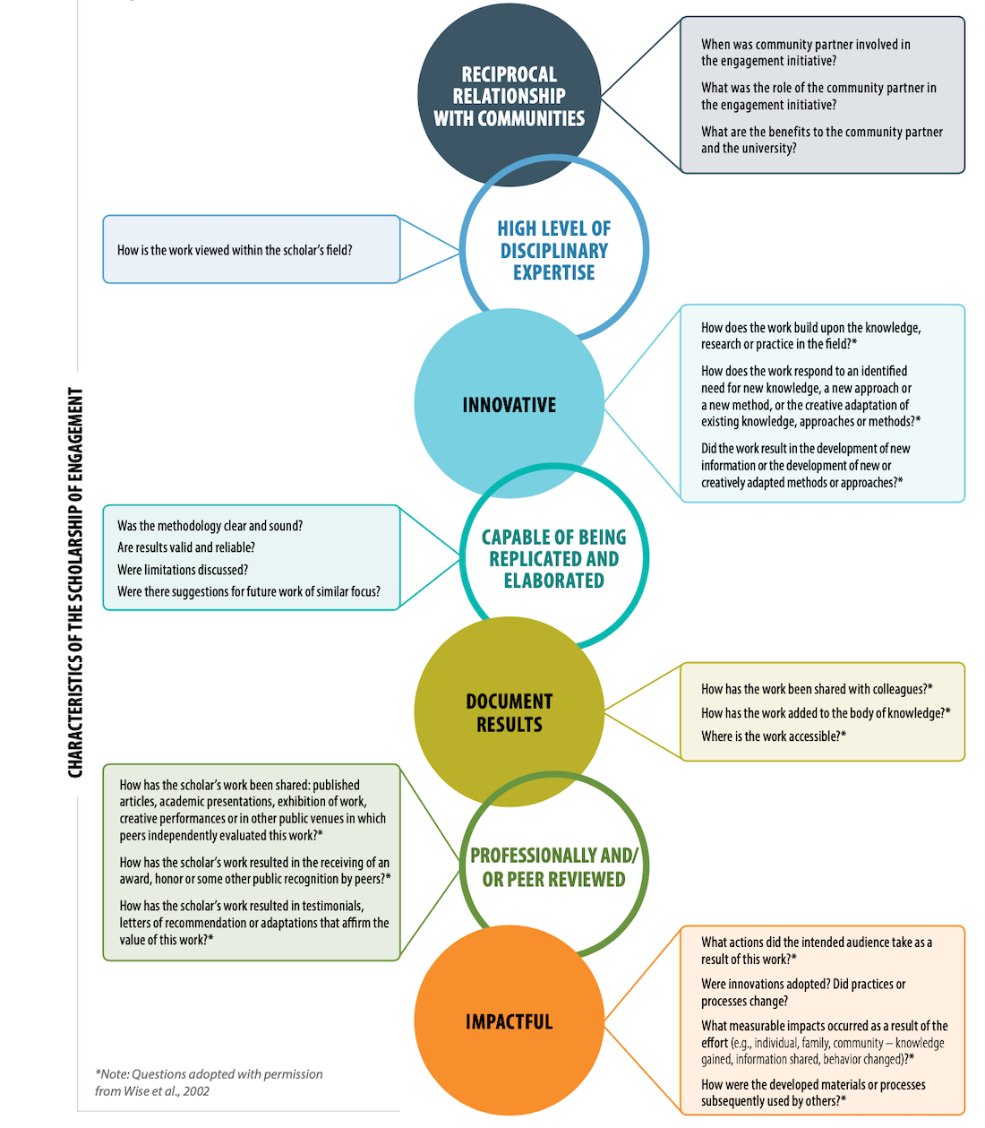

Policy drafted by CLA Strategic Plan Equity Task Force Team 4, Spring 2023
Co-leads: Raven Pfister & Emily Berquist Soule
Equity Task Force Members: Linna Li, Jacqueline Lyon, & Varisa Patraporn

References
American Council on Education. “Translating Equity-Minded Principles into Faculty Evaluation Reform,” 2022.
Beaulieu, Marianne, Mylaine Breton and Astrid Brousselle. “Conceptualizing 20 Years of Engaged Scholarship: A Scoping Review.” PloS One 13:2.
Boyer, Ernest L. “Scholarship Reconsidered,” Carnegie Foundation for the Advancement of Teaching, Princeton, NJ, 1990.
_____. “The Scholarship of Engagement,” Bulletin of the American Academy of Arts and Sciences 49:7 (April 1996), 18-33.
_____. “The Scholarship of Engagement,” Journal of Higher Education Outreach and Engagement 20:1 (2016), 15-27.
Purdue University. “The Guide: Documenting, Evaluating, and Recognizing Engaged Scholarship,” 2017.
University of Minnesota. “Assessment of Community-Engaged Scholarship,” 2018.
https://faculty.umn.edu/faculty-review-recognition/promotion-tenure-review/community- engaged-scholarship
Worcester Polytechnic Institute. "Multiple Forms of Scholarship Matrix," 2019-2020.

