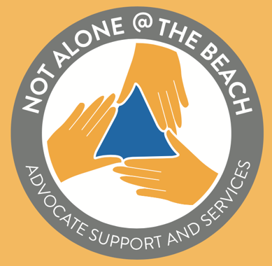
Not Alone @ the Beach Ambassador Program
Spring 2023 | NATB Ambassador
INTERNSHIP APPLICATION

Internship description: NATB ambassadors act as liaisons between CSULB student groups and NATB, assisting with such activities as tabling at campus events, attending classes to talk about NATB events and services, as well as helping to develop and deliver information campaigns, initiatives, and activities. Ideal ambassador candidates are students with significant experience working with key student groups on campus (in Residential Life, Student Clubs, ASI, Greek Life, Athletics) and who are interested in further developing their leadership skills in advocacy, prevention, and social change initiatives. Ambassadors are supervised by the lead NATB graduate assistant and must meet once weekly for training and review purposes. If selected, successful completion of introductory NATB leadership training is required (two-day intensive training, beginning of each semester). This position is paid ($16/hour) and entails 5-6 hours of work each week (in person and virtual) for sixteen weeks.

To apply: Complete the following questions in a Word document, and send along with a current resume, via email to Leena Bowman, project graduate assistant, at leena.bowman01@student.csulb.edu. Application deadline: Nov. 1, 2022.

Name:

Email address:

Best days and times to be reached:

Coursework, school and/or work experience that prepares you for this role:

Future career goals:

How Not Alone @ the Beach fits with those career goals:

Anything else you would like the NATB team to know:

For more information about NATB internships, contact Leena Bowman @ leena.bowman01@student.csulb.edu.

Thank you.

